**REPLICATION**

* Enable multi branch and multi store from

Tools-> application settings->application features

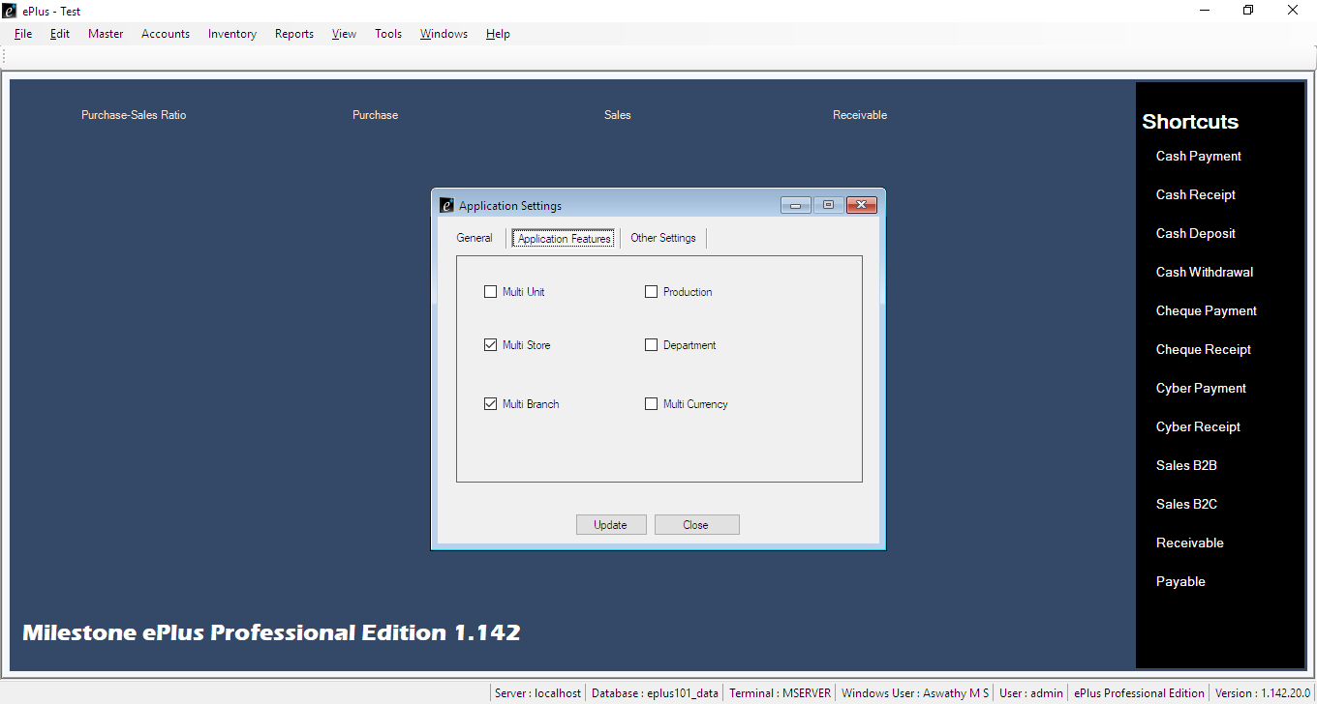

* Create Branches from Tools->settings->Branch . Then assign user, store .
* Add all types of customers(Global ,Loyality,Local-HO,Local-CLT,Local-KNR).

Settings->Chart of accounts->Asset->current asset->sundry debtors->(right click)new.

Make all local customers protected.

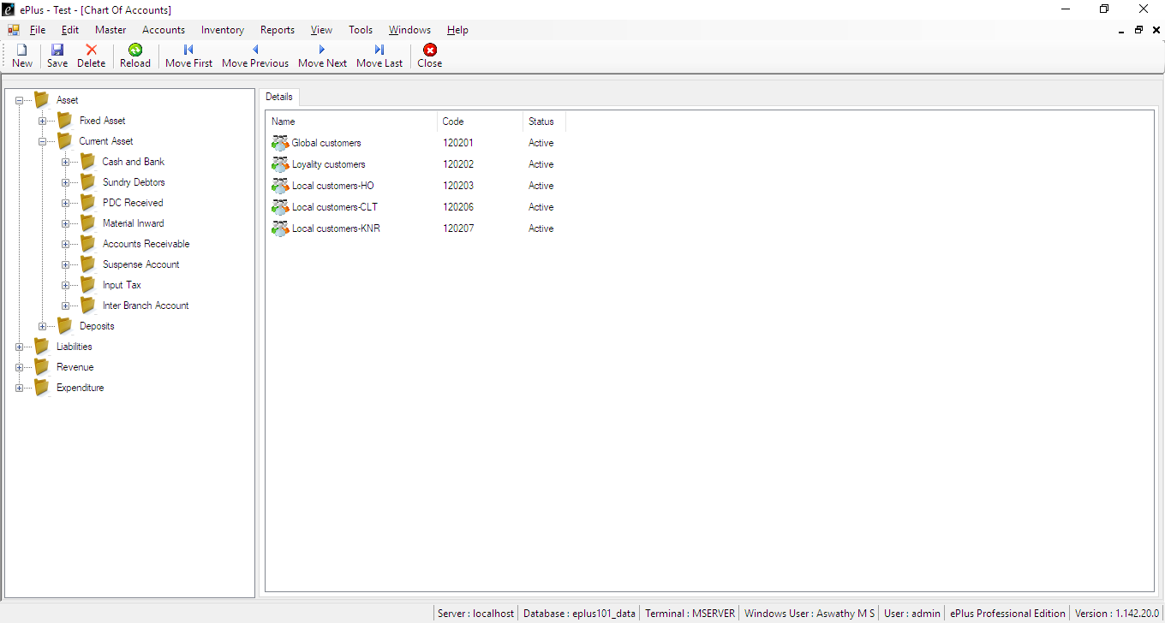

* Settings->account code settings-> customer account->(right click) New code-> add all types of customers(Global,Loyality,Local).

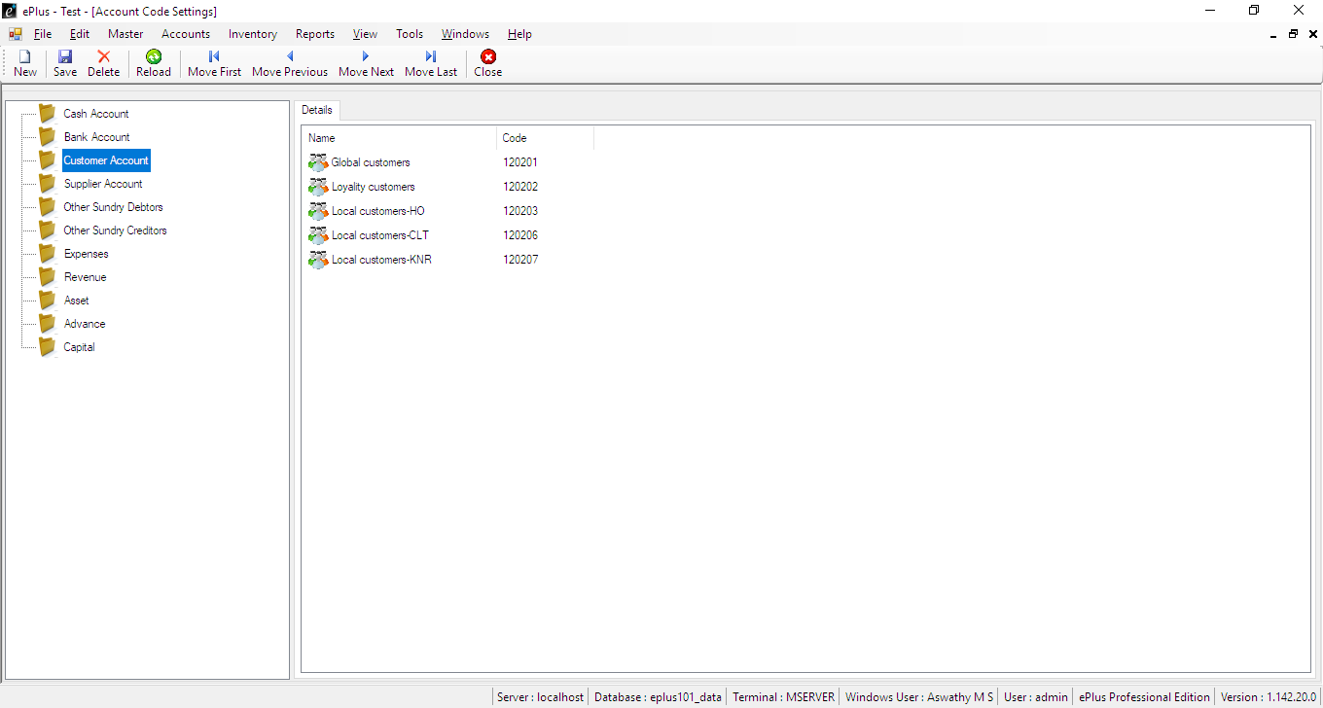

Make customers protected in branch access

Settings->Function Settings->Account Master->customer(right click)->edit

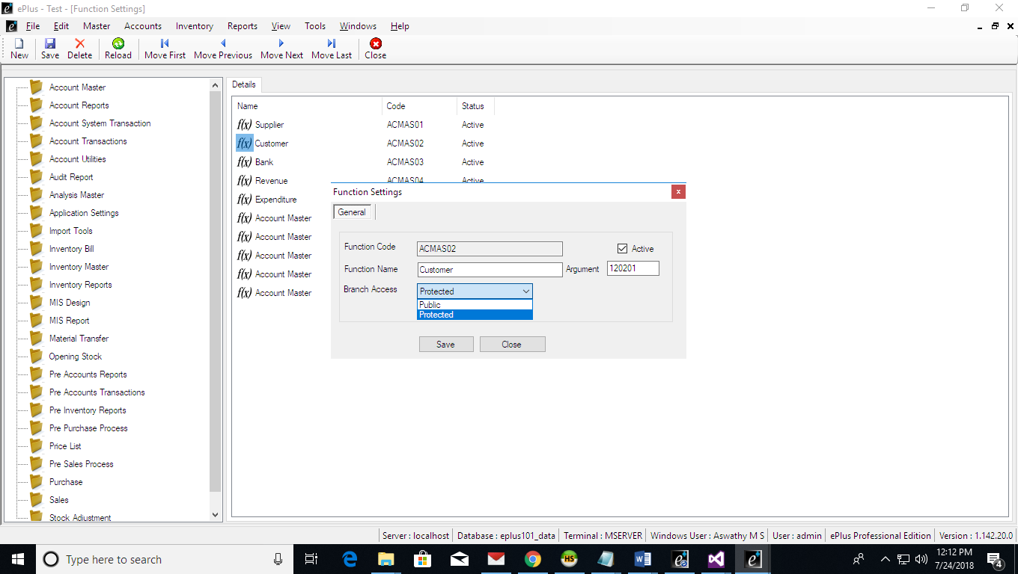

* Assign Account and Funtion in Branch.

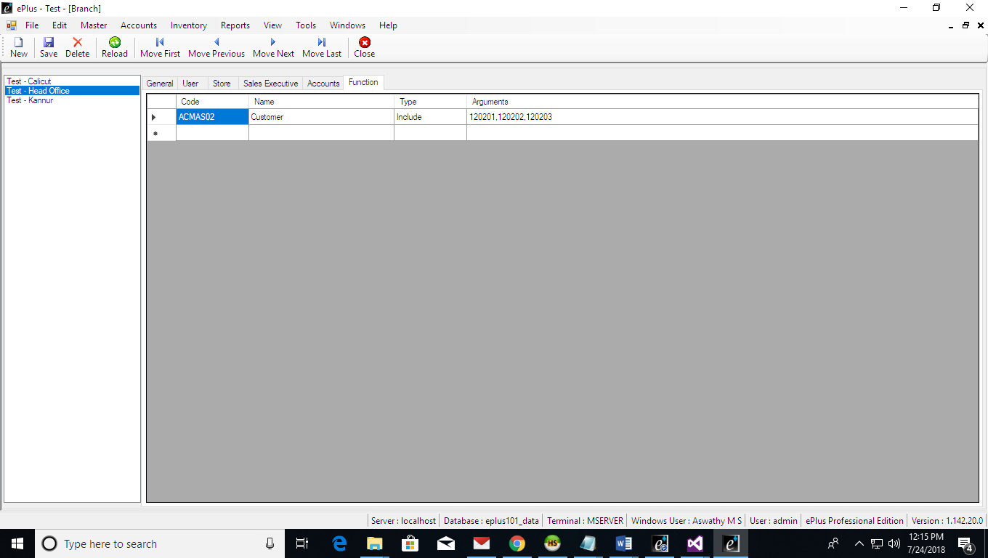

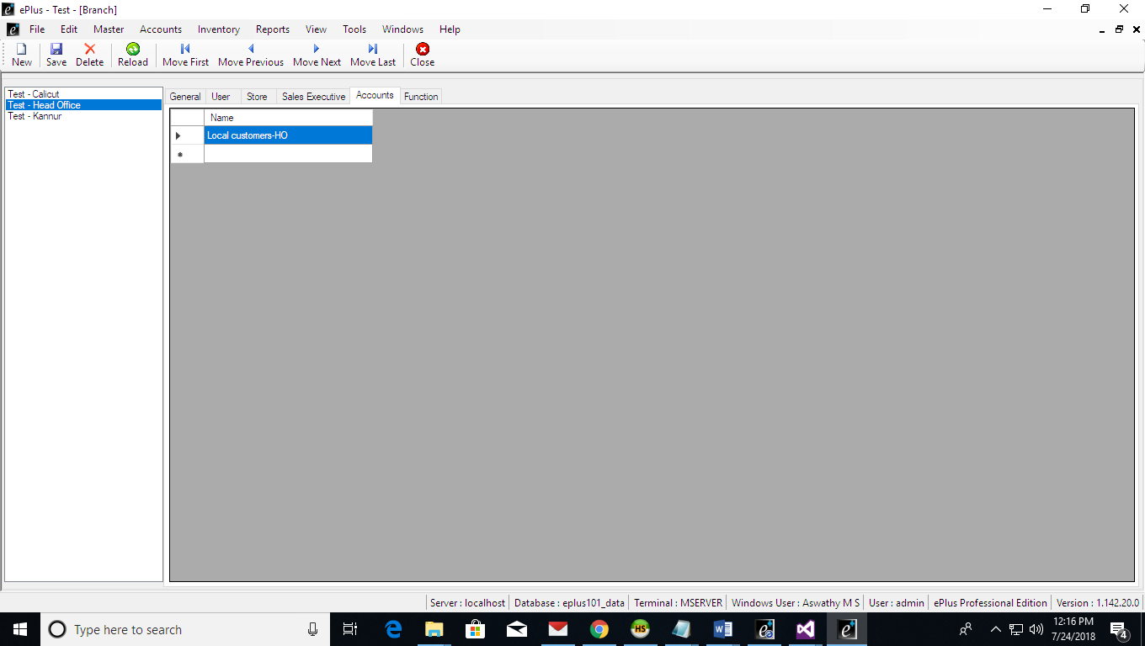

* Create Sales Executive for each Branch.

Goto Master->Sales Executive->(right click)New group->

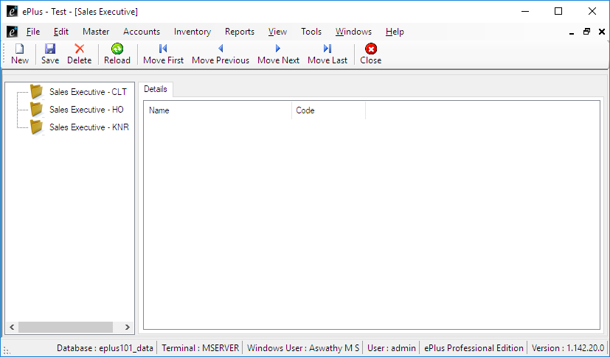

* Assign Sales Executive in Branch. Code should be different for different branches.

